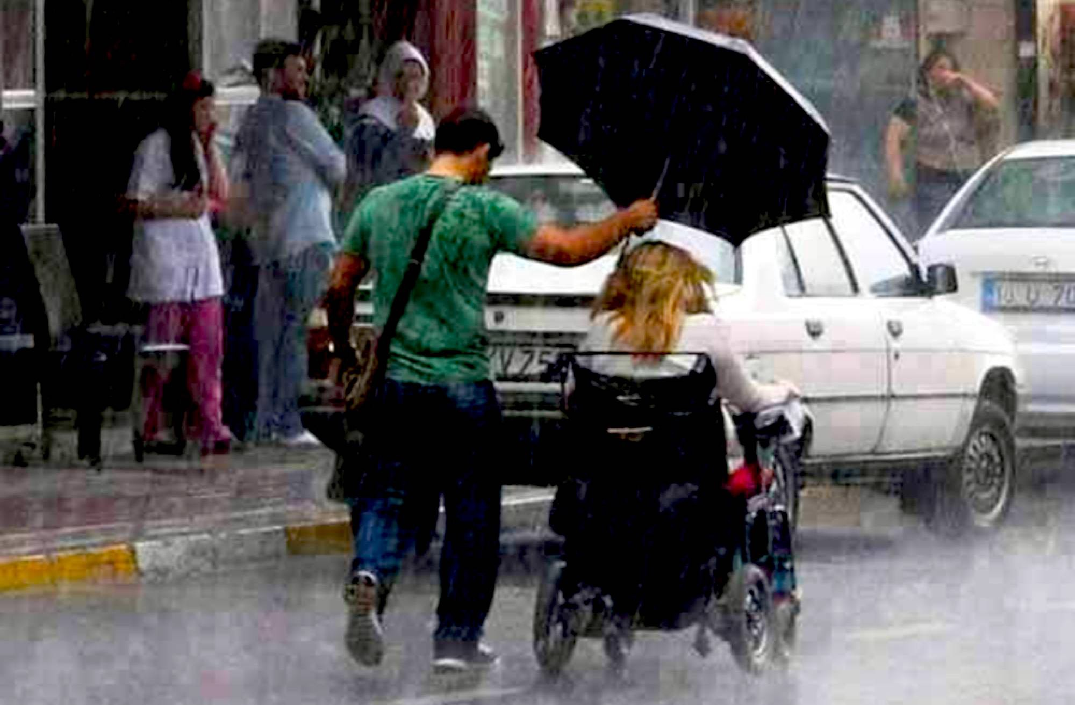

From Bing.com: Images of acts of kindness

The Power of Kindness
By Dr. Sally
I am going to first be sharing a personal experience I had recently receiving help from strangers, then I will proceed to include many other examples and information about the power of kindness to make a difference in people’s lives.
I was visiting my son-in-law, Jeffrey and daughter, Orchid, in Tacoma Washington after she gave birth to a beautiful baby boy, Simon. I had come to help out and bask in love and the joy of grandmotherhood. I was staying at an air B & B for one of the two weeks of my visit and at a friend of Orchid and Jeffrey for the second one. I was having a wonderful time being helpful grandma when I came down with a terrible sore throat near the time I was supposed to be moving to the next place. Worried about spreading germs to the young family and baby, I went to a walk-in clinic and was told: “It’s just a virus, not strep throat, get some throat spray and wash your hands, the baby will be fine.” Relieved, I went on helping out and moved the next day. Before I moved, I noticed two different people having terrible coughs, I asked one of them what it was and was told it was a virus that started with a sore throat. I became a bit worried, but let it go, not wanting to give any energy to being sick.
The day after I moved, I began to feel sick. The couple I was staying with came home and the woman, Dianne, came down to introduce herself and came towards me with arms open for a big hug. I said: just an air hug, I’ve got a, a.” “A something” she interrupted and I agreed. She said she’d see me in the morning and left. That night, as you may guess, I got worse and worse, coughing all night, no sleep. I decided to take myself to the local walk-in-clinic again in the morning, I couldn’t go see my baby grandson like this.
The next day as I was headed out, Dianne asked if I was feeling better. No, I said, and told her I was taking myself to the walk-in-clinic. She asked me if I would like her to drive me, in a tiny relieved voice I said “yes, I’d love you to drive me, I’m quite sick.” We went to the clinic and they examined me and recommended that I go to the Emergency Room, Dianne drove me there and waited while they began treatment. After an hour, I phoned her and told her to go home, I didn’t know when they were going to be finished. She said her husband, Doug, brought us lunch & she would just bring it up to me & then go home, telling me to call when I was ready to leave the ER. I was more and more amazed at being so cared for by both of these wonderful people, who asked nothing in return, and were just loving, kind people. When my treatment was finished, they came and got me, took me to the pharmacist to get my prescriptions filled and brought me back. For the next few days as I recovered, they checked on me to see if I needed anything.
Additionally, the Sunday of my visit was Mother’s Day and I was desperate to get better so I could be with my daughter for her first Mother’s Day, but I was still too sick. Jeffrey surprised me with a basket from Orchid with a gift and lots of home remedies which also very helpful for my recovery. I was again overwhelmed with the kindness of Orchid and Jeffrey, coming to support me when I was supposed to be there for them.
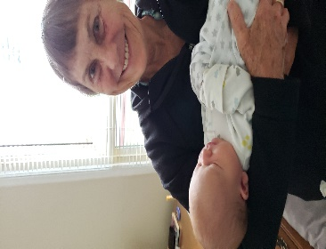
Because of all their caring gestures I was able to recover enough to spend the last three days of my time with Jeffrey, Orchid, and baby Simon. And more importantly, I felt something change for the better inside of me. I am usually in the role of the ‘helper’ to others, and this experience was profound for me to be on the receiving end. The kindness of Doug and Dianne who started out strangers and became like family as well as Orchid and Jeffrey supporting me when I was to be supporting them touched me to my soul. It inspired me to write this article, share my experience with you and do more research on the power of kindness. Perhaps it was the kindness that was the most healing for me. On a deep level, it showed me that I am worthy of receiving; that there are guardian angels flying around us all in the form of strangers as well as family; angels that will help us when we are most in need. (Dr Sally & Baby Simon.)
Researching this topic, kindness, has been an amazing delight and I have found statistics that show, despite what the conventional media indicate with their scare stories of malice and terror on the part of humans, there are actually way more actions of kindness, compassion and caring. The world is essentially a safer, more loving and caring place than the nightly news indicates. Here’s an example from Australia: “Aussies experience more acts of good than ill by 38% to 1%,” Mark McCrindle. He also states that: “Perceptions of worsening violence and less kindness is perpetuated by media crime reports” McCrindle and Wolfinger compiled their book to offset that negative perception and feel that we need “the Power of Good” for our future survival as a species. They found that: “59% of Aussies said that without acts of kindness, their lives would be worse.” I believe these statistics to be true of more than just Australians, probably everyone, everywhere would have similar sentiments, even in the worst circumstances: wars, prisons, homeless, there are stories of kindness extended and even lives saved.
Did you know that humans have a ‘morality molecule’? Well, we do, it is Oxytocin (not to be confused with the painkiller OxyContin) and it is a reproductive molecule, particularly active in childbirth, helping women with contractions, necessary for opening to 10 centimeters, so babies can be born. Women who get stuck at fewer than 10 cm, are given the synthetic version, Pitocin. But it is not only in women, neuroscientist researcher Paul J. Zak found that all humans have this molecule and when it surges in the bloodstream, we are kinder, more cooperative, generous and caring, even with strangers. He found that this surge happens when you show someone a sign of trust. “When one person extends himself to another in a trusting way, the one being trusted experiences a surge of oxytocin that makes her less likely to hold back or cheat. The feeling of being trusted makes a person more trustworthy.” Zak informs us that our bodies already know The Golden Rule: Do unto others that you would have them do unto you. “When we get it right, we feel the rewards immediately, varying from better health, longer and happier life, and a more prosperous economy,” So, dear readers, every time you extend your hand to a fellow human, you increase your own and the other’s sense of well-being. It’s as simple as that, any act of kindness, compassion, or empathy you express is duplicated in the other person. The continual surging of oxytocin in my bloodstream from the kindness I was receiving, not only helped to heal me, but inspired me to inspire you.
Medical Intuitive and inspirational author, Carolyn Myss writes: “There is an invisible power of grace moving between giver and receiver; the action may be small, but the energy channeled through the action is the high-voltage current of grace.” Myss believes the power of grace is what animates our “seemingly impersonal but intimately connected universe” and that “grace holds together the whole of our life---and all of our lives collectively. It watches over us and will come to our aid if we ask.” She states that “Nothing is impossible when you have faith---in yourself and your purpose.” Myss believes that God (If you are uncomfortable with that word God, you can substitute Great Spirit or Consciousness of the Universe or anything that indicates the Universe is a Conscious Force, and the source of Consciousness itself.) operates anonymously, through the invisible powers of faith, love, and grace. We are in “Earth School,” she says, and “We’re on this planet to learn to be spiritual beings in a physical body, to gain consciousness of our greater purpose in life.” She asked readers and subscribers to her website to send her stories of their experiences of “grace and life-changing acts of service.” And was “honored and overwhelmed to receive 1200 letters within six days.” These letters were proof that it doesn’t matter “how much money you have, no matter what sex, race, or age you are, you do have power” and you “can make a difference in your world and the life of every single person you encounter.” (Italics Myss.) She discovered, through reading those letters that it is through giving, helping others in need, giving a hand, a smile, a pat on the back that we express and experience our power and the power of good. “The warm glow we get from helping others is not just a good physical feeling” (not just oxytocin) “it is the energy of healing grace that moves between the giver and the receiver and blesses both.” The stories she received and that she recorded in her book remind us “that we are not alone” and “renew our faith in a guiding force greater than ourselves.” They show us that “the grace that happens to others---interventions, spontaneous healings, or the kindness of strangers---can also happen to us.” When you read such stories (and I discovered many, many books of them by just requesting ‘books on the kindness of strangers’ from my Amazon Kindle) you will have the opportunity to, as Myss says: “realize how much power you have as an individual to make a difference in the life of every person you meet---through your own invisible acts of power.”
Below you see images of acts of kindness: A man risked his life to save a kangaroo during Queensland floods; A policeman bought new books for a homeless man; Meghan Vogel, Ohio track star, helps a runner across the finish line at a State competition.
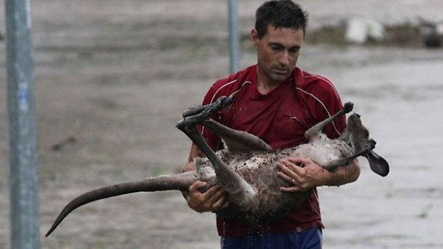
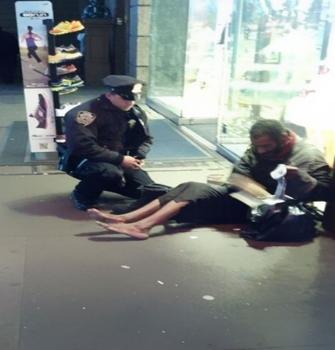
So dear reader, seize your power for kindness, compassion and empathy, you will receive it back many times over and help the world to become a kinder and better place. If you have any stories of giving or receiving kindness, no matter how small, please feel free to share them with the Prophet, we cannot have too many such stories, they give us faith in one another and are a blessing to read.

Mark McCrindle with Emily Wolfinger, editors, The Power of Good: True Stories of Great Kindness from Total Strangers, Melbourne/Victoria, Australia: Hybrid Publishers, 2011. You can get the e-book version of this delightful book for only $3.99 from Amazon.
Ibid.
Ibid. See also his books Trust Factor: The Science of Creating High-Performance Companies, and Moral Markets: The Critical Role of Values in the Economy.
Paul J. Zak, The Moral Molecule: The Source of Love and Prosperity, NY: Dutton/Penguin Group USA, Inc., 2012.
Ibid.
Ibid.
Carolyn Myss, Invisible Acts of Power: Channeling Grace in Your Everyday Life, NY: Atria Paperback, eBook; Simon & Schuster, 2013.
Ibid.
9. Ibid
Ibid.
Ibid
Ibid.
All 3 of these pictures are from the website Memolition, entitled ‘Random Acts of Kindness,’ 1st from herald sun.com.au, 2nd from nytimes.com, 3rd from huffingtonpost.com; there are many images of kindness on the web available, just type in ‘images of kindness’ and you will see.

